

|  |
| --- |
| **Development of a python zip file password cracker**  **By Myles Daniels 2104397**  CMP320: Advanced Ethical Hacking  2023/24 |

*Note that Information contained in this document is for educational purposes.*

Abstract

This section should be an **attention grabber**. It should provide a short summary of what your paper is about so provide enough detail that allows the reader to decide if the report is of interest. This section is stand alone and should not refer to any other part of the document.

**Note: - Do not use I or we in an academic report!!**

**Note: - The Abstract should be before the TABLE OF CONTENTS and don’t number it. Remember, it’s separate from the body of the report.**

You should include 3 short sections (it may be an idea to use 3 different paragraphs):

• Background to the paper and aim of what you’re trying to achieve.

• What you did (and how). (**past tense**)

• What you found and what you conclude from your findings (not too much detail but enough to show that your project was clearly wonderful). Not all projects are a success – and that’s ok too for the purpose of this work, and you can point that out – but preferably with possible solutions. (**past tense**)

Contents

1 Introduction 1

1.1 Background 1

1.2 Aim 1

2 Procedure 2

2.1 Overview of Procedure 2

2.2 Sub-Heading 2

3 Discussion 4

3.1 General Discussion 4

3.2 Countermeasures 4

3.3 Future Work 4

References 5

Appendices 7

Appendix A 7

Appendix B 7

Appendix C - Suggestions for formatting figures/tables/screenshots in the body of the text 7

# Introduction

## Background

Zip Files are Used in all sorts of

## Aim

The aims of this project. Perhaps use bullet-points in places for clarity.

* Be general (high-level) to begin with but also be specific.
* Clearly state. What did you expect to do in this project?

# Procedure

## Overview of Procedure

In the previous section you have explained the problem in detail. **Now describe how you went about your work.** Information of note (e.g. the main things of interest found by nmap) should be in here but large amounts of information should be put in the Appendices (e.g NMAP scans etc).

**NOTE 1: From now on use Past Tense.**

**NOTE 2: Don’t use “and” in a heading. E.g. SCANNING & ENUMERATION are two things so they shouldn’t be in the same heading.**

* It is a good idea to start a Procedure off with a brief overview of what is about to come. Bullet points or numbered lists may help with the overview. It avoids “*and this and this and then this*” type paragraphs/sentences.
* There should not be **too** much detail since you are aiming at a technical user (e.g. a fellow student).
* **Screenshots of important features should be included here** – with descriptions. If it is a hardware project then pictures / diagrams should be included here. These should be clearly labelled (for example “Figure 1 list of wireless LANS”) **and referenced** in the text. For example “see Figure 1 for an example of the results at this stage in the project”.
* There should not be too many screenshots. Only screenshots containing important information should be included.
* There should be **no analysis** of the results at this stage. This will be looked at in the discussion.
* Note that a reader should be able to re-create your work from this description. When you write this section, keep this in mind.

## Sub-Heading

* Use as many sub-headings in the Procedure as you think are necessary
* Put your results in the Procedure here. Any tables or results should be included here unless there is a large amount of data. Note that Appendices should be used for large amounts of data and referenced in the text**.**
* **Remember only important details should be included in this section but you must include ALL the important details. i.e. what you did and what was important about what you found.**

# Discussion

## General Discussion

Here, you want to discuss your results/outcomes.

* What does it all mean? Discuss anything of interest. How does this relate to other work in this area (if relevant)?
* Relate the findings back to your aims - how well have you met your aim?

## Countermeasures

* Discuss countermeasures where appropriate.

## Future Work

* What would you do if given more time and resources?

# References

**For URLs, Blogs:**

Bremer, J. 2012. *x86 API Hooking Demystified*. [blog]. 2 July. Available from: [http://jbremer.org/x86http://jbremer.org/x86-api-hooking-demystified/api-hooking-demystified/](http://jbremer.org/x86-api-hooking-demystified/)[Accessed 15 April 2016].

Bremer, J. 2012. *x86 API Hooking Demystified*. [online image]. Available from: <http://jbremer.org/x86-api-hooking-demystified/>[Accessed 15 April 2016].

Google Chrome. 2016a. *Manifest File Format*. [online]. Available from:

<https://developer.chrome.com/extensions/manifest>[Accessed 15 April 2016].

Google Chrome. 2016b. chrome.webRequest. [online]. Available from: <https://developer.chrome.com/extensions/webRequest>[Accessed 15 April 2016].

Lelli, A. 2010. *The Trojan.Hydraq Incident: Analysis of the Aurora 0-Day Exploit*. [blog]. 21 January. Available from: [http://www.symantec.com/connect/blogs/trojanhydraq-incident-analysis-aurora-0http://www.symantec.com/connect/blogs/trojanhydraq-incident-analysis-aurora-0-day-exploitday-exploit](http://www.symantec.com/connect/blogs/trojanhydraq-incident-analysis-aurora-0-day-exploit)[Accessed 15 April 2016].

**For Books:**

Dahl, R., 2004. *Charlie and the chocolate factory*. 6th ed. New York: Knopf.

**For Citations in Books:**

Desikan, S. and Ramesh, G., 2006. *Software testing*. Bangalore, India: Dorling Kindersley, p.156.

**For Chapters in Books:**

Bressler, L., 2010. My girl, Kylie. In: L. Matheson, ed., *The Dogs That We Love*, 1st ed. Boston: Jacobson Ltd., pp. 78-92.

**For Journals:**

Ross, N., 2015. On Truth Content and False Consciousness in Adorno’s Aesthetic Theory. Philosophy Today, 59(2), pp. 269-290.

**For Journals Accessed via a Database/Website:**

Raina, S., 2015. Establishing Correlation Between Genetics and Nonresponse. *Journal of Postgraduate Medicine*, [online] Volume 61(2), p. 148. Available at: http://www.proquest.com/products-services/ProQuest-Research-Library.html [Accessed 8 Apr. 2015].

For other examples see: <http://libweb.anglia.ac.uk/referencing/harvard.htm>

# Appendices

Note that Appendices should be referenced in the main body of the text.

## Appendix A

Put any large amounts of data here (e.g. code).

**Hello.Php**

<html>

<head>

<title>PHP Test</title>

</head>

<body>

<p>Hello World</p>

</body>

</html>

## Appendix B

And here….

## Appendix C - Suggestions for formatting figures/tables/screenshots in the body of the text

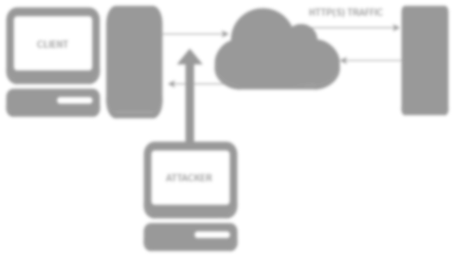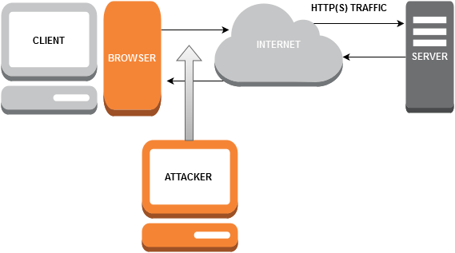

**Figure 1-1** A diagram of the system that was used in the security test.

**Table 1-1** Advantages of the X versus Y

|  |  |
| --- | --- |
| **Advantage Description** | |
| **1** | Can be programmed easier. |
| **2** | More flexible that the traditional system. |
| **3** | More secure than the traditional setup. |

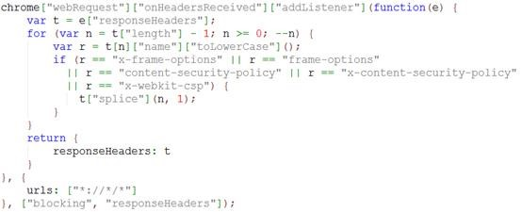

**Figure 1-1** Snippets of code can be formatted like this.